*Florida International University*

*School of Computing and Information Sciences*

Software Engineering Focus

Feature Document

User Story #**895**

**Team Member:**

Daylin Gonzalez Miguel

**Product Owner(s)**:

Eddy Garcia

**Mentor(s)**:

NA

**Instructor**: Masoud Sadjadi

**User Story** Add picture and video upload options to the registration page

* As a developer, I need to add pictures and videos upload options so users can upload pictures or videos to their profiles

Acceptance Criteria

* Users can upload pictures
* Users can upload videos

**Use Case** #**895 –** Add picture and video upload options to the registration page

|  |  |
| --- | --- |
| **Name** | **Upload profile picture** |
| **Brief Description** | **The Upload profile picture use case allows the User to upload a picture when creating an account.** |
| **Actor(s)** | **Guest** |
| **Flow of Events** | |
| **Basic Flow** | |
| **This use case starts when the User accesses the system feature that enables him/her to create an account.**  **1. The User creates an account entering email and password**  **2. The system displays a page for the user to enter required information including a picture**  **3. The user enters the information and upload a picture**  **4. The system validates the enteredinformation**  ***5.* The values for the *User Account* information and the picture are stored in the User’s account.**  ***6.* The use case ends** | |
| **Alternate Flows** | |
| **Title** | **Description** |
| **User Enters Invalid Picture Information** | **If during Create Account, the system determines that the User entered invalid *picture* information, the following occurs:**  **1. The system notifies that the entered data was invalid.**  **2. The system prompts the User to re-enter the invalid information.**  **3. The User re-enters the information and the system re-validates it.**  **4. If valid information is entered, the picture information is stored.**  **5. If invalid information is entered, the Entered Picture Information is Invalid alternative flow is executed again. This continues until the User enters valid information.**  **Invalid *Picture* information:**  **- Pictures with wrong format**  **- Non pictures** |
| **Pre-Conditions** | |
| **Title** | **Description** |
| **User created account** | **The User created an account by entering a valid email and password.** |
| **Post-Conditions** | |
| **Title** | **Description** |
| **Success** | **The User entered picture is stored in the user account.** |
| **The user picture was not saved** | **The User entered invalid data. No picture will be saved.** |
| **Extension Points** | |
| **None** | |

**Use Case** #**898 –** Add video upload options to the registration page

|  |  |
| --- | --- |
| **Name** | **Upload profile video** |
| **Brief Description** | **The Upload video use case allows the User to upload a video when creating an account.** |
| **Actor(s)** | **Guest** |
| **Flow of Events** | |
| **Basic Flow** | |
| **This use case starts when the User accesses the system feature that enables him/her to create an account.**  **1. The User creates an account entering email and password**  **2. The user enters the required information**  **3. The user enters the additional information and upload a video**  **4. The system validates the enteredinformation**  ***5.* The values for the *User Account* information and the video are stored in the User’s account**  ***6.* The use case ends** | |
| **Alternate Flows** | |
| **Title** | **Description** |
| **User Enters Invalid Video Information** | **If during Create Account, the system determines that the User entered invalid *video* information, the following occurs:**  **1. The system notifies that the entered data was invalid.**  **2. The system prompts the User to re-enter the invalid information.**  **3. The User re-enters the information and the system re-validates it.**  **4. If valid information is entered, the picture information is stored.**  **5. If invalid information is entered, the Entered Video Information is Invalid alternative flow is executed again. This continues until the User enters valid information.**  **Invalid *Video* information:**  **- Videos with wrong format**  **- Non pictures** |
| **Pre-Conditions** | |
| **Title** | **Description** |
| **User created account and saved required information** | **The User created an account by entering a valid email and password and saved required information.** |
| **Post-Conditions** | |
| **Title** | **Description** |
| **Success** | **The User entered video is stored in the user account.** |
| **The user video was not saved** | **The User entered invalid data. No video will be saved.** |
| **Extension Points** | |
| **None** | |

**Use Case Diagram**

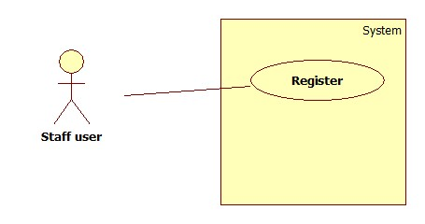

**Sequence Diagram**

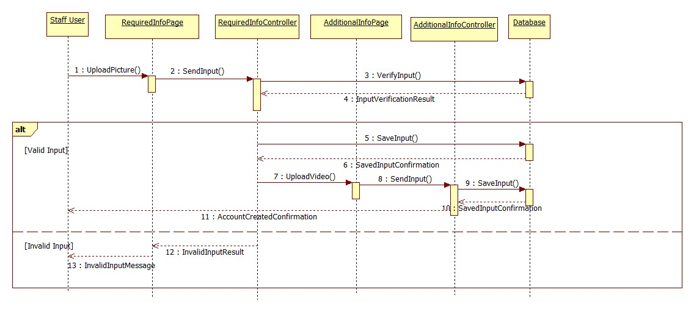

**Class Diagram**

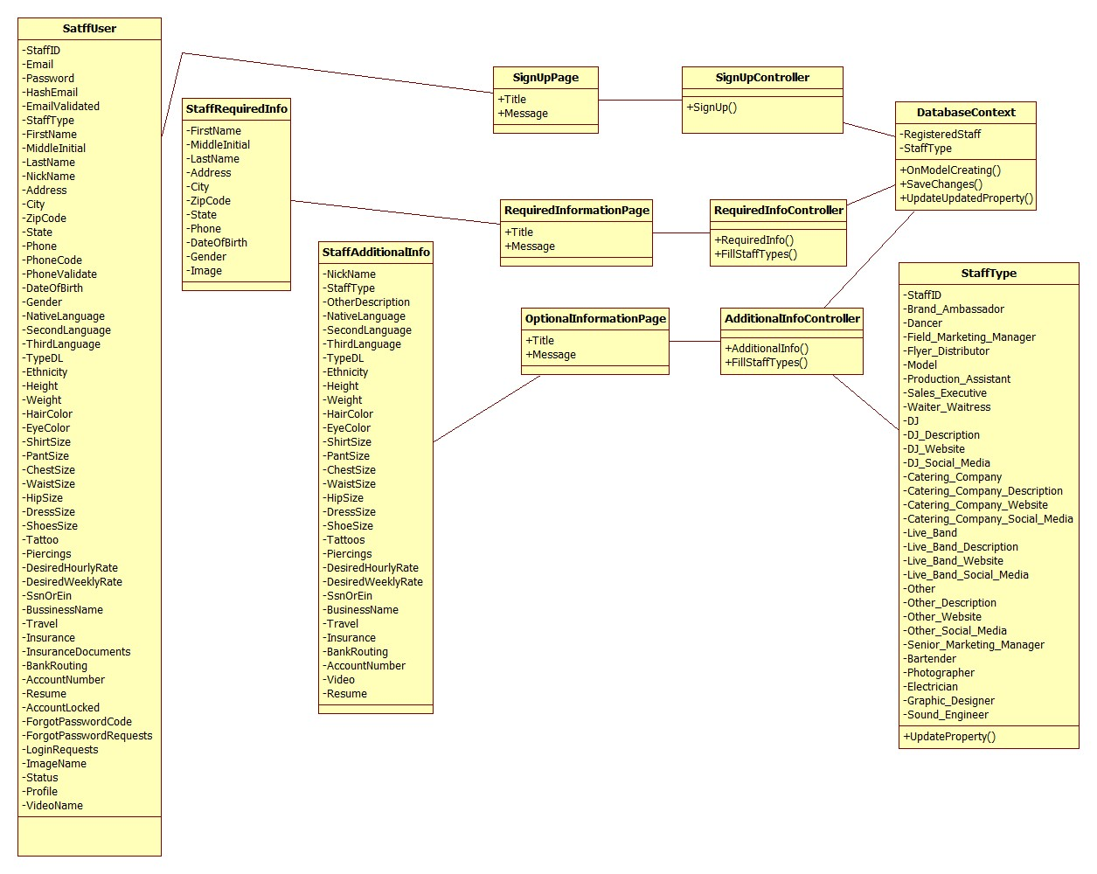

**Unit Test**

|  |
| --- |
| **Test ID: UT-009** |
| **Purpose: Test that the RequiredInfo(entry) method**  **in the RequiredInfoController class saves the picture to a local folder and saves the information in the database** |
| **Preconditions: Application is running, user uploads a picture and clicks Next button** |
| **Input: 3.jpg** |
| **Expected Output: The new picture is saved to a local folder and the information is saved in the database** |

|  |
| --- |
| **Test ID: UT-010** |
| **Purpose: Test that the RequiredInfo(entry) method**  **in the RequiredInfoController class validates that the picture file is in a valid format** |
| **Preconditions: Application is running, user uploads a picture and clicks Next button** |
| **Input: 3.mov** |
| **Expected Output: The page displays a message : "Please choose either a JPG, TIF, GIF or PNG image."** |

|  |
| --- |
| **Test ID: UT-011** |
| **Purpose: Test that the RequiredInfo(entry) method**  **in the RequiredInfoController class creates a folder named as the staff id inside the uploads/pictures local folder to save that user’s picture** |
| **Preconditions: Application is running, user uploads a picture and clicks Next button** |
| **Input: 3.gif** |
| **Expected Output: The folder uploads/pictures/1235/3.gif is created** |

|  |
| --- |
| **Test ID: UT-012** |
| **Purpose: Test that the RequiredInfo(entry) method**  **in the RequiredInfoController class validates that the user uploads a picture** |
| **Preconditions: Application is running and user clicks Next button** |
| **Input:** |
| **Expected Output: The page shows a message "Field can't be empty"** |

|  |
| --- |
| **Test ID: UT-013** |
| **Purpose: Test that the AdditionalInfo(entry) method**  **in the AdditionalInfoController class saves the video to a local folder and saves the information in the database** |
| **Preconditions: Application is running, user uploads a video and clicks Submit button** |
| **Input: 3.mov** |
| **Expected Output: The new video is saved to a local folder and the information is saved in the database** |

|  |
| --- |
| **Test ID: UT-014** |
| **Purpose: Test that the AdditionalInfo(entry) method**  **in the AdditionalInfoController class validates that the video file is in a valid format** |
| **Preconditions: Application is running, user uploads a video and clicks Submit button** |
| **Input: 3.jpg** |
| **Expected Output: The page displays a message : "Please choose either a AVI, FLV, WMV, MOV, or MP4 video."** |

|  |
| --- |
| **Test ID: UT-015** |
| **Purpose: Test that the AdditionalInfo(entry) method**  **in the AdditionalInfoController class creates a folder named as the staff id inside the uploads/videos local folder to save that user’s video** |
| **Preconditions: Application is running, user uploads a video and clicks Submit button** |
| **Input: 3.mov** |
| **Expected Output: The folder uploads/pictures/1236/3.mov is created** |

|  |
| --- |
| **Test ID: UT-016** |
| **Purpose: Test that the AdditionalInfo(entry) method**  **in the AdditionalInfoController class validates that the Resume file is in a valid format** |
| **Preconditions: Application is running, user uploads a resume and clicks Submit button** |
| **Input: resume.txt** |
| **Expected Output: The page displays a message : "Please choose either a DOC, DOCX, TXT, PDF, or RTF document."** |

|  |
| --- |
| **Test ID: UT-017** |
| **Purpose: Test that the AdditionalInfo(entry) method**  **in the AdditionalInfoController class creates a folder named as the staff id inside the uploads/resumes local folder to save that user’s resume** |
| **Preconditions: Application is running, user uploads a resume and clicks Submit button** |
| **Input: resume.docx** |
| **Expected Output: The folder uploads/pictures/1248/resume.docx is created** |

**Integration Test**

|  |
| --- |
| **Test ID: IT-003** |
| **Purpose: Verify whether the user is able to upload a picture and a video** |
| **Preconditions: Internet browser is open and application is running** |
| **Input: { Email = daylin25125@yahoo.es, FirstName = "John", MiddleInitial = “”, LastName = "Winston", Address = “40 Sidonia Ave”, City = “Coral Gables”, ZipCode = “33134”, State = “FL”, Phone = “7865518745”, DateOfBirth = “12/15/85”, Gender = “Female”, Picture = “pic.jpg”, StaffType = “Dancer”, NativeLanguage = “Spanish”, SecondLanguage = “English”, ThirdLanguage = “”, TypeDL = “”, Ethnicity = “”, Height = “5’6””, Weight = “130”, HairColor = “Black”, EyeColor = “Green”, ShirtSize = “S”, PantSize = “27”, ChestSize = “”, WaistSize = “”, HipSize = “”, DressSize = “M”, ShoeSize = “ 37”, Tattoos = “No”, Piercings = “Yes”, DesiredHourlyRate = “”, DesiredWeeklyRate = “”, SsnOrEin = “458785412”, BusinessName = “”, Travel = “ Yes”, Insurance = “No”, BankRouting = “1234567890”, AccountNumber = “123456789”, Video = “video1.mov”, Resume = “resume.docx” }** |
| **Expected Output: The account is created and the confirmation page shows up** |

**Visual User Guide**